**NAME**

**COLLEGE NUMBER**

**QUESTION ONE**

**Array functions in JavaScript**

Arrays are used to store data of any variable type and retrieve them whenever need be. They can store data of all types from strings, integers, Booleans and floats. Across most programming languages, arrays have also been used to solve most programming and algorithm solutions to problems. Typically, an array will pick a variable memory value with the array elements printed inside a brackets and then the elements in the arrays separated by a common. Example of s JavaScript arrays is as show below

const myArray = [ 321100, true, Monday, {}]

The above array function takes the keyword cost, which is used to declare the name of the array holding the data and the give it a name called myArrray after which we pass into the array the values that are supposed to be held in the array. In the example above, we have stored an integer Boolean, string and an object not inside the JavaScript object .Also, the position of an array is called its index and rather than beginning from 1, it usually begins from 0. For instance, in the code above, the ideal position are the array elements are as shown below:

0 = 321100

1 = true

2 = Monday

3 = {}

Given any number of array elements inside an array will determine its length. In our case above, the array length is 4, since the number of elements in the array is four. Each element therefore in the arrays can be accessed by the position of the array within it.

The above snippet of JavaScript code accesses the array based on its position in the element.

const fruits = ['orange', 'guacamole','onion', 'chilly', 'banana']

console.log(fruits)

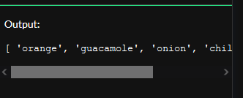

We can also access the array element from back of the array using its positions are below;

const fruits = ['orange', 'guacamole','onion', 'chilly', 'banana']

const len = fruits.len

fruits[len -1];

fruits[len-3];

**Array functions in Php**

Unlike in JavaScript, we use arrays in php to store variables of a given time, for instance we can store integers, strings and Booleans in different integers values as below;

<?php

$age = 23;

$name = 'Mathew Simons';

$gender = 'male';

$married  = 'yes'

?>

Further, we can store more elements just like JavaScript within an array just by using a single variable and assigning the elements inside the variable in PHP as below.

<?php

$post_info = array(

    'Simon Mathews',

    'New York and New Jersey',

    'Harvad Univesrity'

);

?>

When we want to access an element position in PHP, we just call its position in the arrays such as below;

<?php

$post_info = array(

    'Simon Mathews',

    'New york jersey',

    'Harvad Univesrity'

);

echo $post_info[0];

?>

The above program, code will return the name of the array position at index 0 as below;

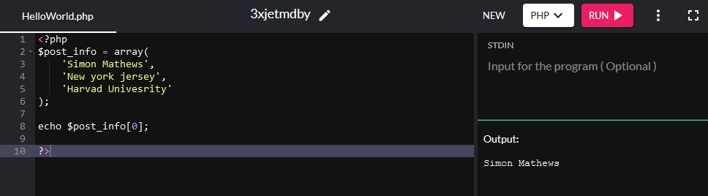

However, what makes PHP arrays more fun is the ability to use your own variable names to the elements within at the main variable as below:

<?php

$post_info= array(

    'name' => 'Simon Mathews',

    'state' => 'New York',

    'college' => 'Harard University'

);

echo $post_info['name'];

?>

When we run the above code, we get the below output;

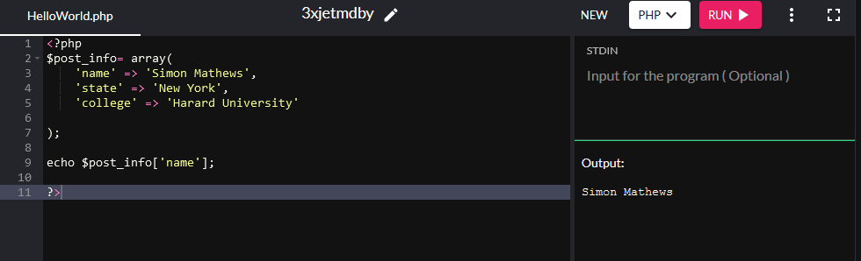

One major difference between arrays in php and python is that in Python, you can easily iterate over a given list to access the elements whereas in PHP you aces the elements by their positions.

B.)

- Missing closing comma here que.append(‘Bank Telle 2)

-Incorrect key word for append here que.appen(‘Bank Teller 3')

-Missing insert index position

-Incorrect spelling for teller que.append(‘Bank Telle 2)

**Question 2**

If we consider the scenario in a bank, a customer coms in and selects ticket numbers for the particular services that they want. A customer may not arrive at exact time when he or she is supposed to be, the first one in the system, but most likely, they will arrive at either somewhere midway. The bank teller will serve the customers based on first priority, the customer who came first will be served first and then the next and like that. This scenario is called first in first out FIFO

In a computer printer, we set the document and ages that we want to print, the computer will queue the documents appropriately and set the pages to print, once the print command has been issued to the printer, the printer will print the documents based on the first page that was introduced in that order till the last page, this queue stack is called FIFO

In email systems, messages continuously flow into the inbox, whereas it’s not a guarantor that the message that came in forts will be the first to be read, however, priority is always given to the last message that appears on the top list as priority. This kind of queue stack is called LIFO, last in last out.

import queue

q1 = queue.LifoQueue()

q1.put(10)

cat1 = q1.get()

print('LIFO removed from queue is:', cat1)

**Question three**

In the example of DHL, we can consider two types of data structures i.e. Lists and queue stacks. We can use lists to showcase an example category of clients that the company has who ship cargo across the globe and their locations, this can be illustrated as below;

DHLcountries = ['Morroco','Spain', 'USA','Singapore']

print("\nList of countries: ")

print(DHLcountries)

The above list shows the countries that DHL operates in. Alternative, if we consider a queue stack at DHL, customers occasionally come and book cargo shipment, and if we go by the principle of first in fist out, the clients who book their cargo for shipping a day before will have their cargo shipment processed ahead of the rest who come in later.

from collections import deque

cargoStack = deque()

cargoStack.append('a')

cargoStack.append('b')

cargoStack.append('c')

cargoStack

deque(['a', 'b', 'c'])

cargoStack.pop()

'c'

cargoStack.pop()

'b'

cargoStack.pop()

'a'

cargoStack.pop()

**QUESTION 4**

|  |  |
| --- | --- |
| List | Array |
| Can have elements of different data types | **Can have only elements of same data type** |
| Modules implementations are needed | **Does not need module imports** |
| May not directly be used in arithmetic operations | **May be used in arithmetic operations** |
| Most preferred for smaller data sequences | **Most preferred for larger data sequences** |
|  |  |

**QUESTION 5**

Al Dunia Mineral tree based data structure

This kind of tree structure helps in:

* Ensuring information follows the right channels
* Ensuring a chain of command within the company
* Ensuring that decision making structure is followed from top to bottom
* Ensure that all key participants are engaged in the decision making process
* Ensures process work managed by helping the mangers handles tasks within their territorial domain

B.)

In the milk manufacturing factory, once the milk has been properly packaged and packed, the milk packets move to a trail where they are checked for serials, those milk packets that are missing the correct and required serial are extracted form the queue and returned to the package station X for repacked and re-serial. This type of algorithm is called linear search the system scans the serials and when the machine fails to find the correct serial, it’s removed from queue. It’s beneficial because it reduces time in finding the packet with no serials, however, there is the risk of other milk packets passing out during power outage situations.

**REFERENCES**

Dubois, P. F., Hinsen, K., & Hugunin, J. (1996). Numerical python. Computers in Physics, 10(3), 262-267.

Liang, Y. D. (2013). For Introduction to Programming Using Python. displays, 8(8), 8.

McMillan, M. (2014). Data Structures and Algorithms with JavaScript: Bringing Classic Computing Approaches to the Web. " O'Reilly Media, Inc.".